Q1.list of all Rooms with description

---Query 1: CPU time = 0 ms, elapsed time = 202 ms.

CREATE or ALTER VIEW vRoomDetails

AS

SELECT r.id, t.description

FROM room r

INNER JOIN room_type t

ON r.room_type = t.id ;

GO

select * from [dbo].[vRoomDetails]Test 1: select *

Table 'room'. Scan count 4, logical reads 8

Table 'room_type'. Scan count 1, logical reads 2

CPU time = 0 ms, elapsed time = 68 ms.

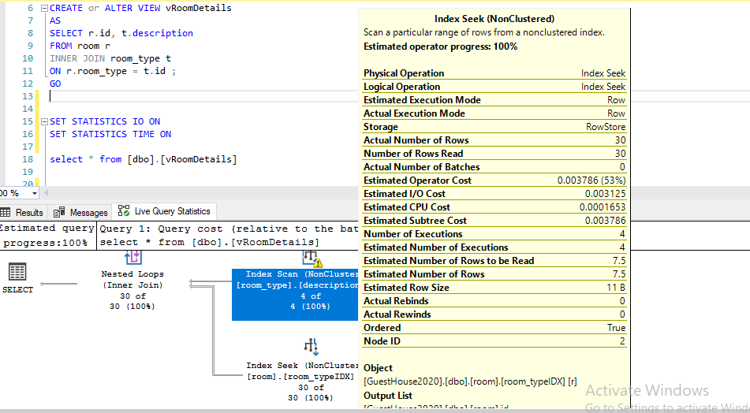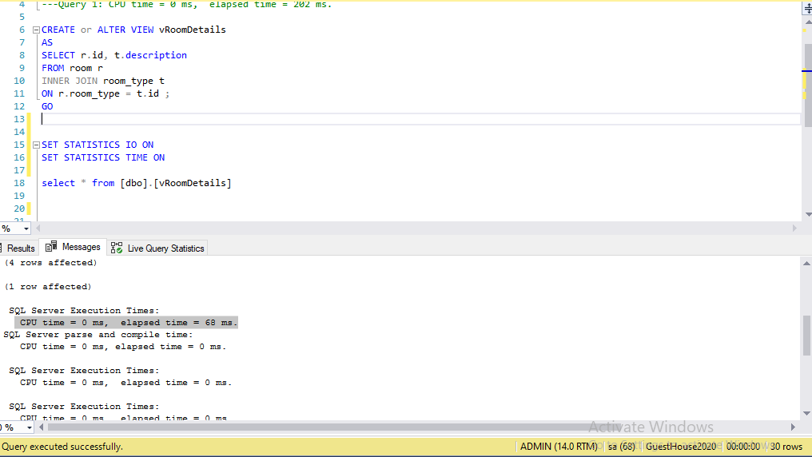

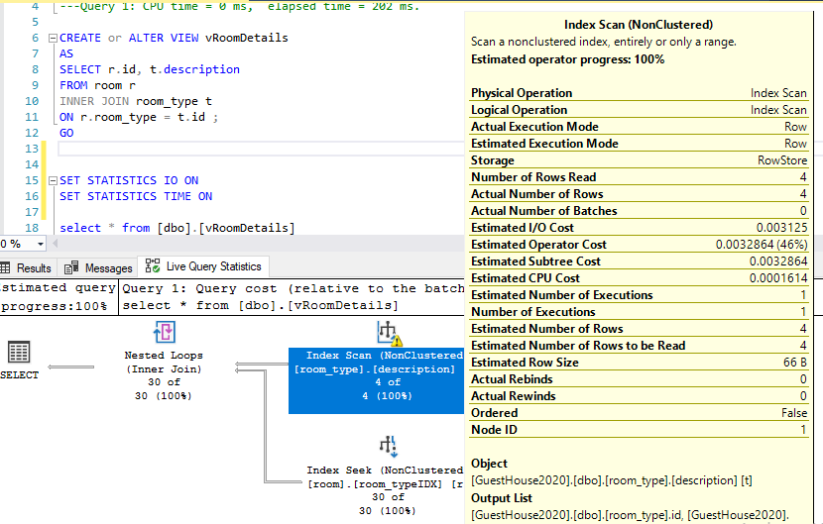

CONCLUTION:

This is a good query. As we can see in Query Statistics, index seek and index scan process have number of rows read equal to actual number of rows . I would say this is a efficient query. So I don’t carry on more optimizations.